Spring 2009 Qualifying Exam

Part I

Calculators are allowed. No reference material may be used.

Please clearly mark the problems you have solved and want to be graded. Do only mark the required number of problems.

Physical Constants:

Planck constant: h = 6.6260755 × 10⁻³⁴ Js,  = 1.05457266 × 10⁻³⁴ Js
Boltzmann constant: k_{B} = 1.380658 × 10⁻²³ J/K
Elementary charge: e = 1.60217733 × 10⁻¹⁹ C
Avogadro number: N_{A} = 6.0221367 × 10²³ particles/mol
Speed of light: c = 2.99792458 × 10⁸ m/s
Electron rest mass: m_{e} = 9.1093897 × 10⁻³¹ kg
Proton rest mass: m_{p} = 1.6726231 × 10⁻²⁷ kg
Neutron rest mass: m_{n} = 1.6749286 × 10⁻²⁷ kg
Bohr radius: a₀ = 5.29177 × 10⁻¹¹ m
Compton wavelength of the electron: λ_{c} = h/(m_{e} c) = 2.42631 × 10⁻¹² m
Permeability of free space: μ₀ = 4π 10⁻⁷ N/A²
Permittivity of free space: ε₀ = 1/μ₀c²
Gravitational constant: G = 6.6726 × 10⁻¹¹ m³/(kg s²)

Section I:
Work 8 out of 10 problems, problem 1 – problem 10! (8 points each)

Problem 1:
A charge Q is placed a distance D from an infinite slab of non-conducting material with charge density ρ and thickness d. What is the force on the charge?

Problem 2:
The figure shows a wire that carries a current I in the direction indicated by the arrows. The conductor consists of two circular arcs (with radii a and b) and two straight sections. What is the magnitude of the net magnetic field at point P (the common center of the circles).

Problem 3:
A Higgs boson (M = 178 GeV/c²) at rest decays into a pair of leptons (ϕ → τ⁺τ⁻). The τ⁻ has a mass of m = 1.78 GeV/c². What is the recoil β = v/c of the τ⁺?

Problem 4:
An atom has a normalized angular wavefunction
$ψ\left(θ,φ\right)=\frac{1}{\sqrt{3}}Y_{\text{11}}\left(θ,φ\right)+\frac{1}{\sqrt{6}}Y_{\text{21}}\left(θ,φ\right)+\frac{1}{\sqrt{2}}Y_{\text{10}}\left(θ,φ\right)$.
(a) Which values of L² can be measured, and with what probability?
(b) What is the expectation value of L_{z}?

Problem 5:
Two objects are suspended like shown in the figure.

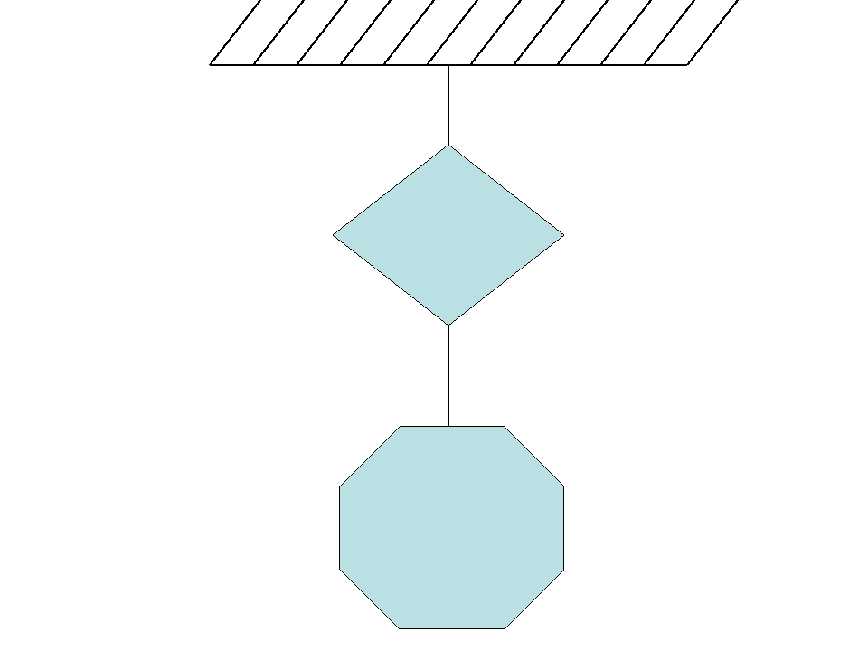
The tension in the upper rope is twice the tension in the lower rope. When this system is submerged into water the layout does not change, but the tension in the upper rope decreases by 20% and tension in the lower robe decreases by 30%. The density of water is 1 g/cm³. What are the densities of objects?

Problem 6:
A block of mass m starts from rest at θ = 0 and slides without friction under the force of gravity on an inverted hemispherical surface of radius R. Find the angle θ when the block leaves the surface.
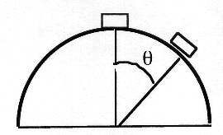

Problem 7:
In the circuit above, express the current in the 3R resistor in terms of V and R.

Problem 8:

A cat and a dog are sitting on the top of a small wagon which is a rest. The mass of the dog is 20 kg and the mass of the cat is 5 kg. There is no friction between the wagon and the ground. The cat jumps from the wagon and then the dog jumps in the same direction from the already moving wagon. When the dog jumps off, the wagon’s velocity increases seven fold. The horizontal components of the dog’s and the cat’s velocities before touching the ground are the same. What is the wagon mass?

Problem 9:
Two perfectly elastic balls the larger of mass M and the smaller of mass m, where m << M, are dropped from a height h >> radius of either ball above a solid surface. Mass M rebounds elastically from the surface and mass m rebounds elastically from M. Find the height H that the small ball reaches in terms of h. You need only find an approximate result in the limit that m/M → 0. The general result depends upon the ratio m/M.
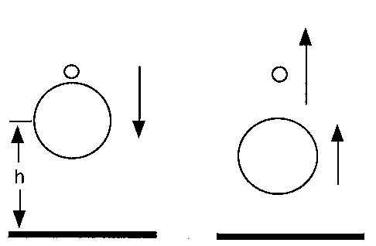

Problem 10:
A rectangular block of dielectric material with permittivity$ε$ is partially inserted between two parallel plane conducting plates. The plates are square, of side l, and are separated by a distance d, with d << l. The dielectric is also square, of side l, and has a thickness of almost d. A potential V is applied across the plates. When the dielectric has a length x inserted between the plates, calculate the force on the dielectric, including its direction.
x
d
ε
ε₀

l

Section II:
Work 3 out of the 5 problems, problem 11 – problem 15! (12 points each)
Problem 11:
A train car of length L’ = L₀ in the train’s frame of reference moves along a track at velocity v_{T} = c/2.
A gunman in the rear of car fires a bullet in the direction of motion of the train. He observes its velocity to be v_{B}’ = c/2. For an observer in the rest frame of the track, what are the values of
(a) L, the length of the car?
(b) v_{B}, the velocity of the bullet?
(c) t₂, the length of time the bullet travels before striking the front of the car?
(d) x₂, the distance the bullet travels?

Problem 12:
An interplanetary spacecraft (of mass m and speed v relative to the Sun) approaches the planet Jupiter (of mass M >> m and speed V relative to the Sun) as shown in the figure. The spacecraft rounds the planet and departs in the opposite direction.
(a) What is the speed, relative to the Sun, in terms of these quantities, after this slingshot maneuver?
(b) Evaluate this speed assuming that the spacecraft was launched from Earth with speed sufficient to just barely escape the solar system and that Earth's and Jupiter's orbits are circular.

mass of Earth = M_{E} = 5.98 x 10²⁴ kg
mass of Jupiter = 318 M_{E}
mass of Sun = M_{S} = 1.99 x 10³⁰ kg
mean radius of Jupiter's orbit = R_{J} = 7.78 x 10¹¹ m
mean radius of Earth's orbit = R_{E} = 1.50 x 10¹¹ m
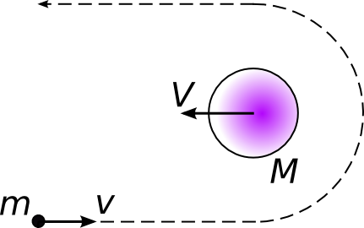

Problem 13:
A particle of mass m is in the ground state of a harmonic oscillator with spring constant
k = mω². At t = 0, the spring constant changes suddenly to k' = 4mω². Find the probability that the oscillator remains in its ground state.
$$\int_{−∞}^{∞}{\text{exp}\left({−x^{2}}/{a^{2}}\right)\text{dx}=\sqrt{π}a}$$

Problem 14:
Derive an expression that describes how the pressure P of a gaseous atmosphere varies with altitude h above the surface of a planet having surface gravitational acceleration g. Assume the atmosphere to be “thin” in the sense that one can neglect the variation of g and the temperature T with altitude, and assume that the atmosphere is composed of gas obeying the ideal gas law and having density and pressure of ρ₀ and P₀, respectively, at the surface of the planet.

Problem 15:
Find the resistance between points A and B. All the individual resistors are 1 Ω.
(a) triangle  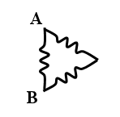 | (b) bridge|  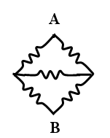
(c) tetrahedron  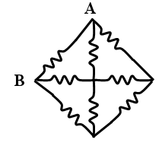 | (d) infinite ladder  