Fall 2009 Qualifying Exam

Part II

Mathematical tables are provided. Formula sheets are provided.

Calculators are allowed.

Please clearly mark the problems you have solved and want to be graded. Do only mark the required number of problems.

Physical Constants:

Planck constant: h = 6.6260755 × 10⁻³⁴ Js,  = 1.05457266 × 10⁻³⁴ Js
Boltzmann constant: k_{B} = 1.380658 × 10⁻²³ J/K
Elementary charge: e = 1.60217733 × 10⁻¹⁹ C
Avogadro number: N_{A} = 6.0221367 × 10²³ particles/mol
Speed of light: c = 2.99792458 × 10⁸ m/s
Electron rest mass: m_{e} = 9.1093897 × 10⁻³¹ kg
Proton rest mass: m_{p} = 1.6726231 × 10⁻²⁷ kg
Neutron rest mass: m_{n} = 1.6749286 × 10⁻²⁷ kg
Bohr radius a₀ = 5.29177 × 10⁻¹¹ m
Compton wavelength of the electron: λ_{c} = h/(m_{e} c) = 2.42631 × 10⁻¹² m
Permeability of free space: μ₀ = 4π 10⁻⁷ N/A²
Permittivity of free space: ε₀ = 1/μ₀c²
Gravitational constant: G = 6.6726 × 10⁻¹¹ m³/(kg s²)

Solve 6 out of the 8 problems! (All problems carry the same weight)

- Problem 1:
- Consider a particle of mass m constrained to remain on the surface of a cylinder of radius b. Let the axis of the cylinder be the z-axis. The particle is subject to the force of gravity mg in the negative z-direction.
(a) Use the Lagrange multiplier method and find the appropriate Lagrangian including a term expressing the constraint.
- (b) Apply the Euler-Lagrange equations to obtain the equations of motion.
- (c) Find the force of constraint and briefly discuss why this value is reasonable and to be expected.
- (d) Now, repeat parts (a) and (b) without using the Lagrange multiplier method. Instead, build the constraint into the general coordinates.

- Problem 2:
A plane wave representing an electron beam with energy E is incident from the negative x direction onto a potential energy step described by the function
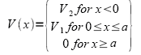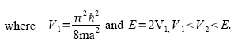
Evaluate the transmittance T. For which value of V₂ is T the largest?

Problem 3:
Use Newtonian gravity to derive an expression for the time to collapse a spherical mass distribution if the only force acting is gravity (the dynamical or free-fall timescale). Use this result to estimate the expected response time of the Sun to a significant gravitational disturbance, given that the radius of the Sun is about 7×10⁵ km and its mass is about 2×10³⁰ kg.

Problem 4:
In one dimension, a particle is in a potential
V(x) = ½mω²x², for x > 0,
V(x) = ∞, for x = 0.
(a) The particle is in its ground state. What is its wave function?
(b) At time t = 0 the hard wall is suddenly removed and replaced by the potential
V(x) = ½mω²x², for x < 0. What is the probability that the particle is in the first excited state of the resulting harmonic oscillator for t > 0.
(c) What is the probability that the particle is in any other odd parity state for t > 0.

Problem 5
(a) Find the photon threshold energy in MeV for the photoproduction process
γ + p → p + π ⁰
(m_{π0} = 135 MeV/c², m_{p} = 938 MeV/c²).
(b) Now consider the following problem. The isotropic CMBR (Cosmic Microwave Background Radiation) of photons in space has a temperature of T = 2.726 K. The most probable photon frequency (distributed according to Plank’s radiation law) is $ν=c/λ=1\text{.}6×{\text{10}}^{\text{11}}\text{Hz}$; the corresponding photon energy is E_{γ} = hν ~ 658 μeV.
Calculate the energy in MeV of a cosmic-ray proton that by interacting with a CMBR photon will produce a pion (π⁰) like in part (a).
(c) Calculate the mean free path of the proton in space for this process if the density of CMBR photons is 411 cm⁻³ and the cross section is 0.5 mbarn (1 barn = 10⁻²⁴ cm²).

Problem 6:
Find the magnetic field B at the center of a flat spiral with current I. The spiral is contained between two radii r and R and has N turns. Do not consider the effect of the connecting wires.
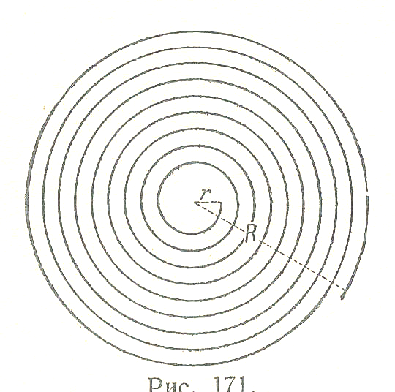
Problem 7:
In one dimension, a system of free particles (on the whole interval - ∞ < x < ∞) is in a state described in momentum space by φ(p) = C exp(-|p|a/).
(a) Find the probability P₁ that the system would be found with a momentum value between –/(2a) and +/(2a).
(b) What is the probability P₂ that a position measurement would find the system between -a and +a?

Problem 8:
One mole of an ideal gas undergoes transformations that take it from point A to point B on a p-V diagram by two different paths α and β. Points A and B have the same temperature T = T₀ (this means that they lie on an isotherm) and the pressure p_{A} at point A is larger than the pressure p_{B} at point B. Path α takes the system from state A to state I through an isochoric (constant volume) transformation, followed by an isobaric (constant pressure) transformation from state I to state B. Path β takes the system from state A to state II through an isobaric transformation, followed by an isochoric transformation from state II to state B. Assume that p_{A} and p_{B} are known.
(a) Find V_{A} and V_{B} in terms of the known quantities p_{A}, p_{B} and T₀.
(b) In a p-V diagram plot path α and path β
(c) Assuming that the heat capacities C_{V} and C_{p} are constants what is the heat flow into the gas for each path? Give your results in terms of p_{A}, p_{B}, T₀, C_{V} and C_{p}. In each case is heat absorbed or released by the system? Why?
(d) In absolute value, for what process is the heat larger? Why?

